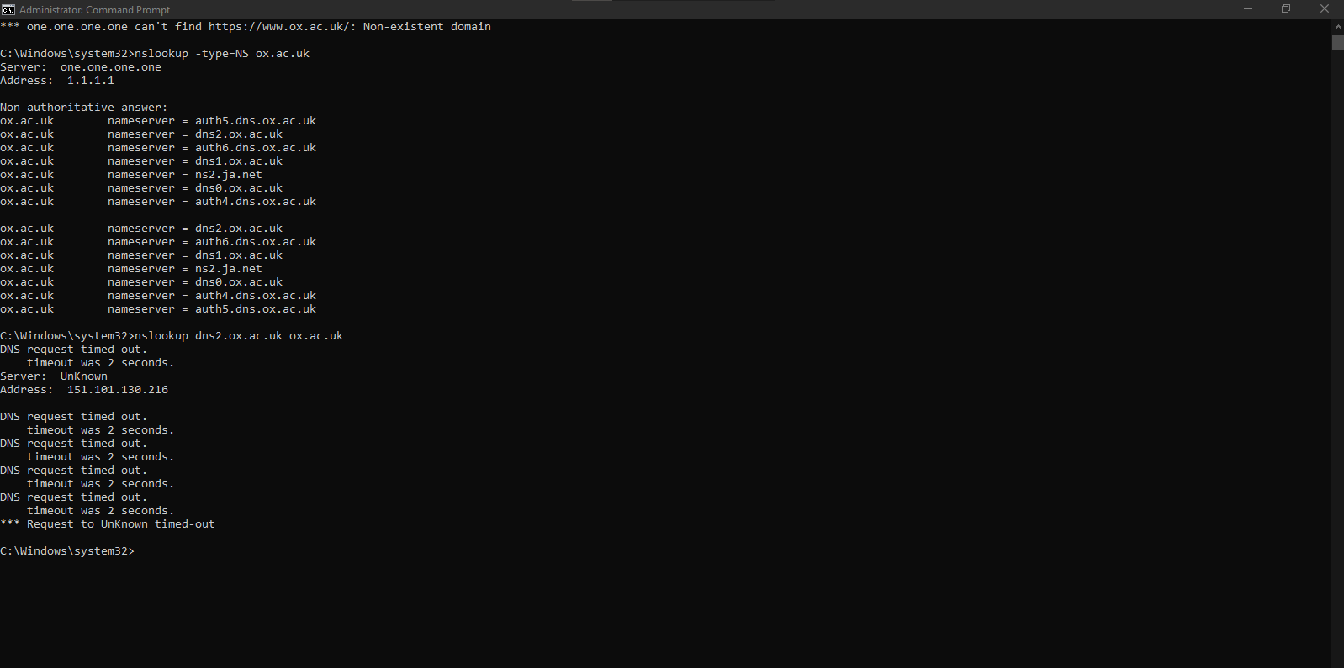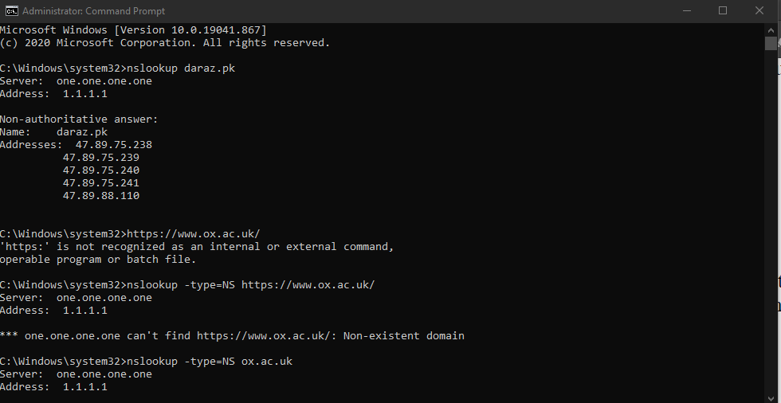

4. TCP

5. Src port: 49979, dest port: 443

6. 216.58.209.138, No

7. 64 Standard Query

8. Application Data